//Card.java

public class Card{

  private int value;

  private String suit;

  public Card(int value, String suit){

    this.value = value;

    this.suit = suit;

  }

  public int getValue(){

    return value;

  }

  public String getSuit(){

    return suit;

  }

  public void setSuit(String suit){

    this.suit = suit;

  }

  public void setalue(int value){

    this.value = value;

  }

  public String toString(){

    return value + " of " + suit;

  }

}

import java.util.\*;

public class Deck {

    private ArrayList<Card> cards;

    public Deck() {

        this.cards = new ArrayList<Card>();

        String[] values = {"A", "2", "3", "4", "5", "6", "7", "8", "9", "10", "J", "Q", "K"};

        String[] suits = {"Hearts", "Diamonds", "Clubs", "Spades"};

        for (int i = 0; i < suits.length; i++) {

            for (int j = 0; j < values.length; j++) {

                this.cards.add(new Card(j + 1, suits[i]));

            }

        }

        Collections.shuffle(this.cards);

    }

    public ArrayList<Card> getDeck() {

        return cards;

    }

    public Card getCard() {

        return cards.get(0);

    }

}

//Main.java

public class Main {

    public static void main(String[] args) {

      Deck deck = new Deck();

      System.out.println(deck.getDeck());

      System.out.println(deck.getCard());

    }

  }

Output :

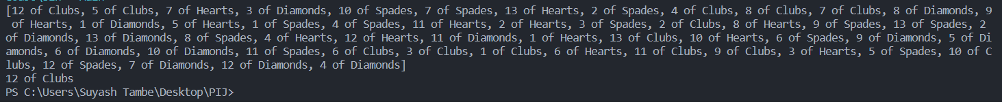

Github link: <https://github.com/suyashtambe/PIJ>